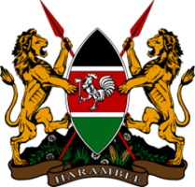
Permanent Mission of the Republic of Kenya
To the United Nations, New York
Security Council -2021-2022

THE SITUATION IN LIBYA
EXPLANATION OF VOTE ON THE MANDATE RENEWAL FOR THE UNITED NATIONS SUPPORT MISSION IN LIBYA (UNSMIL)
FRIDAY 28 OCTOBER 2022
STATEMENT BY MS. CATHERINE NYAKOE, LEGAL ADVISOR
Thank you Mr. President
- During the briefing on the situation in Libya on 24th October, we emphasised the need for UNSMIL to have a substantive one-year mandate.
- Kenya has voted for Resolution 2656 which responds to this need. It provides the stability and predictability for the Special Representative to lead the Mission and steer international support to the peace process with greater certainty.
- It also demonstrates a welcome unity of purpose by the Security Council.
- We thank the UK and fellow members of the Council for their constructive engagement in the negotiations.
Mr. President,
- The Libya peace process is complex at a national level, and made more so by the involvement of competing external interests. They all have their own perspectives, diagnosis and solutions. Combined, and regularly in competition, they undermine the peace and security of Libya. We therefore urge all international support be channeled through this UN-led process.
- We also call on the people of Libya to make use of this framework of support for their collective benefit.
- Finally, Mr. President, we reaffirm our firm support for the people of Libya. We are committed to a truly Libyan-led and owned peace process built upon respect for Libya’s territorial integrity and sovereignty.
Thank you

