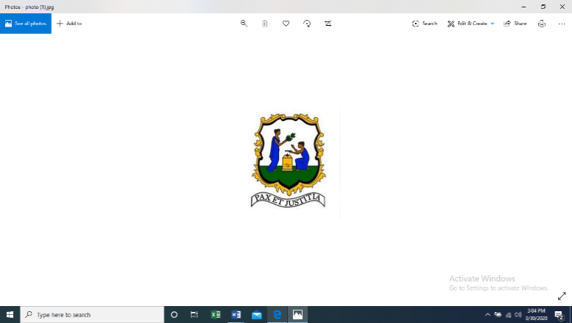

Permanent Mission of Saint Vincent and the Grenadines
to the United Nations
685 3rd Ave., Suite 1108, New York, NY 10017 • Tel: (212) 599-0950 • Fax: (212) 599-1020 •
svgmission@gmail.com | http://svg-un.org

Statement
by
H.E. Inga Rhonda King
Permanent Representative of Saint Vincent and the Grenadines
to the United Nations
The Question Concerning Haiti
United Nations Security Council

06/17/2021

New York

Please check against delivery

I have the distinct honour to deliver this statement on behalf of Kenya, Niger, Tunisia and Saint Vincent and the Grenadines - A3 +1.

We thank Special Representative of the Secretary-General, Ms. Helen La Lime and Ms. Chantal Hudicourt Ewald, for their presentations.

We also welcome the presence of the distinguished Acting Prime Minister of Haiti, H.E. Claude Joseph in today’s deliberations.

Mr. President,

The ever-deteriorating state of affairs in Haiti, as evident by the very grim report of the Secretary General, is extremely troubling.

The political stalemate persists and the recent upsurge in COVID-19 cases risks further exacerbating the already dire socio-economic and humanitarian situation, whilst the temerity and power of gangs compound the security situation.

The prevailing conditions therefore require urgent attention, and specific and sustained support from the international community. Political inertia cannot continue if Haiti is to achieve its aspirations of peace, stability and prosperity.

Consistent with their responsibilities, this Organization, together with CARICOM and the OAS have been urging Haitian leaders and relevant stakeholders to treat decisively with its multi-faceted crises.

In this context, the A3+1 commends the efforts of the Permanent Council of the OAS in undertaking a good offices mission to Haiti last week. We hope that the mission was successful in establishing a framework for dialogue amongst the various Haitian stakeholders, with the aim of reaching a palatable solution. We look forward to the mission’s forthcoming report.

In order to peacefully overcome the current crises through a Haitian-led and Haitian-owned inclusive national political dialogue, all Haitian stakeholders need to soften their deeply entrenched positions so that trust could be built, and dialogue facilitated.

Further, the A3+1 takes this opportunity to remind the Haitian leaders of their international law obligations and the regional commitments to which they have pledged, particularly those enshrined in the Inter-American Democratic Charter and the Charter of Civil Society for the Caribbean Community.

Mr. President,

The A3+1 is deeply disturbed by the security and human rights situation. The lack of progress in the efforts by the Haitian National Police (HNP) to provide the necessary security and protection in the areas under assault, such as Martissant, La Saline, Belair, Ravine and Cite Soleil, is extremely worrying.

High incidence of kidnappings continues apace with ongoing robbery, cruel detention and human rights violation, including sexual and gender-based violence. Additionally, reports continue to emerge with respect to rogue police officers.

The recent request by President Moise for additional support from the United Nations attests to the gravity of insecurity in Haiti.

Accordingly, we call for the strict adherence to the Presidential Statement (S/PRST/2021/7) adopted last March, which emphasized the need for an immediate and coordinated response by Haitian authorities to demonstrate their commitment to addressing the deteriorating security situation in Haiti, including gang-related criminal activities, increases in kidnappings, homicides, and rape.

The A3+1 also echoes its support for the National Commission for the Disarmament, Demobilization and Reintegration in reducing community violence and urges the government to undertake measures to adopt the draft national strategy on community violence reduction. This strategy should bolster the State’s security apparatus to combat criminal activities and dismantle gangs.

Similarly, adopting the National Action Plan on Human Rights endorsed in December 2019 by the Haitian Inter-Ministerial Committee on Human Rights, will be instrumental in bringing justice to the victims.

The dire conditions prevalent throughout the Haitian prison system and judicial deficiencies cannot be divorced from the security challenges. The A3+1 therefore urges the authorities to address bottlenecks within the penitentiary and judiciary systems.

We welcome the establishment of the Board of the Legal Aid Council and its role in the expedition of legal cases. We also align with the Secretary General’s call on the Ministry of Justice and Public Security to establish the committee on the implementation of the penal reform codes without delay, in order to ensure their enactment to tackle the detention rate and serious overcrowding in prisons.

Mr. President,

Resolving the political stalemate appears to be priority for the scheduling of inclusive, free, fair, transparent and credible elections; however, the interconnected nature of Haiti’s many-sided challenges demands durable parallel solutions.

Good governance has become a policy condition for loans, technical assistance and debt relief. It is therefore incumbent for Haitian political leaders to resolve the current impasse to accrue this benefit.

Likewise, we encourage the international community to continue supporting Haiti’s 2021 National Humanitarian Response Plan, which requires US $235.6 million to respond to the needs of 1.5 million people, including 1.3 million who are severely food insecure.

At the same time, we urge the scaling up of COVID-19 vaccines supply in order for our sister nation to respond appropriately to the pandemic and ensure its sustainable recovery.

Finally - to our Haitian brothers and sisters – history has shown us that no matter how difficult your challenges are, you rise. We therefore call on you once more to collectively find sustenance from the tried and tested values of your forebears and unite, reconcile and advance on the path to peace, development and stability.

The A3+1 celebrates your rich and diverse culture as displayed during your heritage month in May, recognizing that Haiti symbolizes the first black nation to gain independence by overcoming colonialism and slavery. To this end, it would be remiss of us not to repeat our call for reparations from former colonial powers to assist in repairing the malignant legacy of slavery.

We believe that within this decade focused on the upliftment of persons of African descent, proper attention must be given to this just cause.

I thank you.

