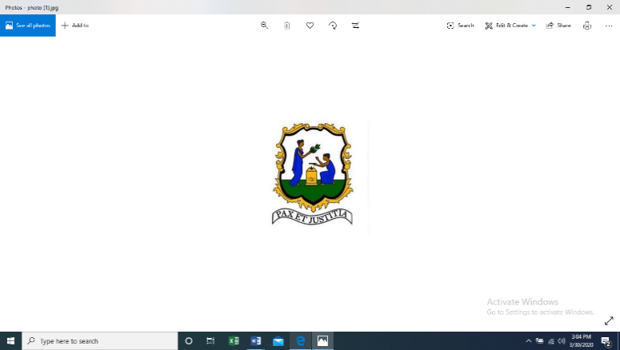

Permanent Mission of Saint Vincent and the Grenadines
to the United Nations
685 3rd Ave., Suite 1108, New York, NY 10017 • Tel: (212) 599-0950 • Fax: (212) 599-1020 •
svgmission@gmail.com | http://svg-un.org

Statement
by
H.E. Inga Rhonda King
Permanent Representative of Saint Vincent and the Grenadines
to the United Nations
The Question Concerning Haiti
United Nations Security Council

02/22/2021

New York

Please check against delivery

I have the honour to deliver this statement on behalf of Kenya, Niger, Tunisia and Saint Vincent and the Grenadines - A3+1. We thank Special Representative of the Secretary-General, Ms. Helen La Lime for her briefing and appreciate BINUH’s effort in Haiti’s stabilization process. We also express our appreciation for Ms. Vivianne Roc, Director of Plurielles Haiti, for her presentation and welcome H.E. Jovenel Moïse, President of the Republic of Haiti.

Madam President,

In a month’s time, the world will be commemorating the international day of remembrance of victims of slavery and the transatlantic slave trade, we will also be celebrating the legacy of the people of Haiti as the first black Nation to gain independence by overcoming colonialism and slavery.

The present situation in Haiti, however, is extremely disquieting. Since our last meeting, the status quo in our sister Caribbean nation remains – the political gridlock lingers, the security situation is volatile and the socio-economic and humanitarian situation continues to deteriorate. Unpredictability looms large and we are greatly concerned that the deepening political impasse has placed the country on a precipice.

In this respect, we echo the call of CARICOM encouraging all parties to engage in meaningful dialogue in the interest of peace and stability and strongly urging that action be taken to foster a safe environment, a return to normal life and the building of sustainable democratic institutions.

The A3+1 continues to follow very closely the highly polarized situation and is concerned about the non-existence of a parliament since January 2020, as a result of the failure to convene overdue legislative elections. We, however, appreciate the development of an electoral timetable and encourage the Haitian political actors to undertake measures, including finalizing logistical arrangements to ensure the convocation of free, fair, inclusive, transparent and credible elections.

We further underscore the need to uphold the rule of law and electoral processes, and stress the importance of being guided by the letter and spirit of the constitutional order, whilst placing the needs and interests of the people at the forefront.

It is our contention that any solution to the current crisis must be Haitian-led and Haitian-owned. We understand that there are strongly held divergent views and tensions are high. As such, it is critical that the parties set aside their differences, build consensus and chart a viable way forward. We also call on the political leaders to convene a national dialogue and commence a period of national reconciliation.

As it relates to security, we are dismayed by the upsurge in violence, in particular, the scourge of gang-related criminal activities, including kidnappings. We are further perturbed by reports of rogue police officers’ involvement in coordinating violent gangs and call for full investigation and accountability for those found culpable. We repeat our support for the National Commission for the Disarmament, Demobilization and Reintegration in reducing community violence and encourage the government to swiftly undertake measures to adopt the draft national strategy on community violence reduction. This strategy would enhance the State’s security machinery to combat criminal activities.

Additionally, we welcome the allocation of resources to the Haitian National Police (HNP). Strengthening this critical institution to ensure that it executes its mandate, including the disruption of criminal networks and syndicates, such as the G9, is pivotal.

Madam President,
The nexus between peace, security and sustainable development is interwoven into Haiti’s human rights situation. The A3+1 deplores the persistent human rights violation, including against the groups made most vulnerable and calls for accountability and the end to impunity. It remains imperative that justice is brought to all victims of atrocities, including the late Monferrier Dorval. In this regard, we underscore the importance of respecting international human rights law.

More specifically, we regret the lack of progress of the judicial investigations into the Livalois, Grand Rivuine, La Saline, Bel-Air, and Pont-Rouge-Cite Soleil cases, as well as the inability to enforce pending warrants for prominent gang members such as Jimmy Cherizier.

Indeed, the lack of accountability facilitates the continuation of gang-related violence. We therefore urge the authorities to spare no effort to ensure that justice prevails for the victims. Adopting the national action plan on human rights endorsed in December 2019 by the Haitian Inter-Ministerial Committee on Human Rights will assist in this regard.

The socio-economic and humanitarian realities require the urgent assistance of the international community with the operationalization of the humanitarian-development-peace nexus. Accordingly, it is essential that donor countries continue contributing to Haiti’s 2021-2022 Humanitarian Response Plan.

Madam President,
The international community has a critical task in providing comprehensive support to assist Haiti in alleviating its complex challenges and legacy of underdevelopment. It is past time that we begin the dialogue process for reparation for the legacies of underdevelopment in Haiti.

We know from the lessons of history, ancient and recent, that peace and development are inseparable. The people of Haiti have already suffered enough. They deserve to live in peace. They deserve a future that offers prosperity. We urge all stakeholders, difficult and complex though it may be, to enter into a constructive dialogue and to work together to build a better Haiti.

The A3+1 reiterates its support to BINUH, CARICOM and the OAS, and renews its call for these organizations and the wider international community, to continue accompanying Haiti in its pursuit for political and socio-economic stability.

Kenya, Niger, Tunisia and Saint Vincent and the Grenadines stand in solidarity with the people of Haiti.

I thank you.

